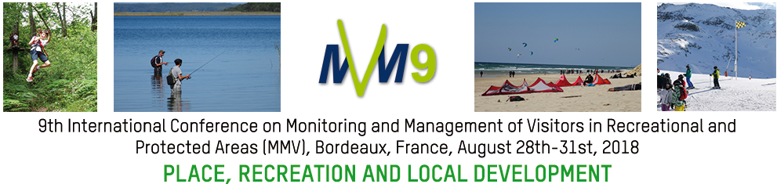

Organized session proposal

Type: open session, oral presentations on a specific topic

Marine protected areas – new requirements for visitor management?
Around the world, and particularly in Europe, more and more marine protected areas (MPAs) are being established or discussed by governments and NGOs. The work with MPAs has been stated to be a priority by EU with direct links to important policy work such as UNs Convention on Biological Diversity, EUs Marine Directive and more recently EUs directive on Maritime Spatial Planning. Like their terrestrial counterparts, MPAs are based on an ecosystem approach with an aim to balance use and protection of marine resources. At the same time, for many countries, MPAs are new area categories that require new planning and management thinking, especially when it comes to visitor management. For instance, in Norway, visitor management in MPAs has proved more challenging than anticipated, as the current protected area management framework, including visitor management, is built on experiences from mountain areas and therefore not adapted to marine conditions. Another example is from Sweden where promotion of “Blue Growth” has put increasing emphasis on the use of MPAs for touristic and recreational purposes, which in turn requires new thinking in terms of managing visitors and their activities. Finally, in the UK there are currently discussions to categorise new areas of protected landscape including MPAs in the southwest of England where a part of the discussion is the role of MPA when it comes to balancing recreation, the tourism industry and protection within the frame of both national policies and Brexit. With this session, we want to engage discussions on the role of MPAs with a special emphasis on recreational and visitor management in these areas. We want to give attention to both opportunities and challenges as well as both long-term and short-term experiences with MPAs and therefore encourage examples from around the world.

Session organizers
Dr. Richard Stones, University of Exeter, r.stones@exeter.ac.uk
Dr. Andreas Skriver Hansen, University of Gothenburg, andreas.hansen@geography.gu.se

